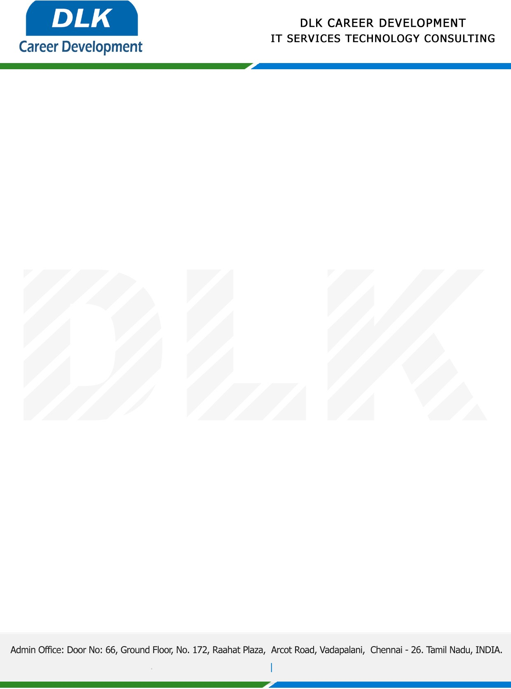

Date: 14 April 2023

**To**

Department of MCA (Master of Computer Application),

Head of Department,

Thirumalai Engineering College, Kanchipuram – 631551.

**Sub: Letter of Project Acceptance**

This is to certify that **MS SIMRAN V (REG NO: 513221622048)** final year student of has accepted the Project Work from April **2023** under the domain **“Java”.** During the project, all information and data collected from you should be kept confidential.

**Topic**: An Efficient Search Method Using Features to Match Joint Keywords on Encrypted Cloud Data.

**“Best Wishes for Your Future Endeavors “**

For **DLK CAREER DEVELOPMENT**

**HR Manager**

**VELMURUGAN J**